**DAILY ONLINE ACTIVITIES SUMMARY**

|  |  |  |  |  |  |  |  |
| --- | --- | --- | --- | --- | --- | --- | --- |
| **Date:** | **03-06-2020** | | | | **Name:** | **K Manasa** | |
| **Sem & Sec** | **8th ''** | | | | **USN:** | **4AL16CS043** | |
| **Online Test Summary** | | | | | | | |
| **Subject** | | **-** | | | | | |
| **Max. Marks** | | **-** | | **Score** | | **-** | |
| **Certification Course Summary** | | | | | | | |
| **Course** | **Python for machine learning** | | | | | | |
| **Certificate Provider** | | | **Great learning** | **Duration** | | | **3hr** |
| **Coding Challenges** | | | | | | | |
| **Problem Statement:C prog to print the no in this serie** | | | | | | | |
| **Status:Solved** | | | | | | | |
| **Uploaded the report in Github** | | | | **Yes** | | | |
| **If yes Repository name** | | | | **Manasa** | | | |
| **Uploaded the report in slack** | | | | **Yes** | | | |

Certification Course Details: (Attach the snapshot and briefly write the report for the same)

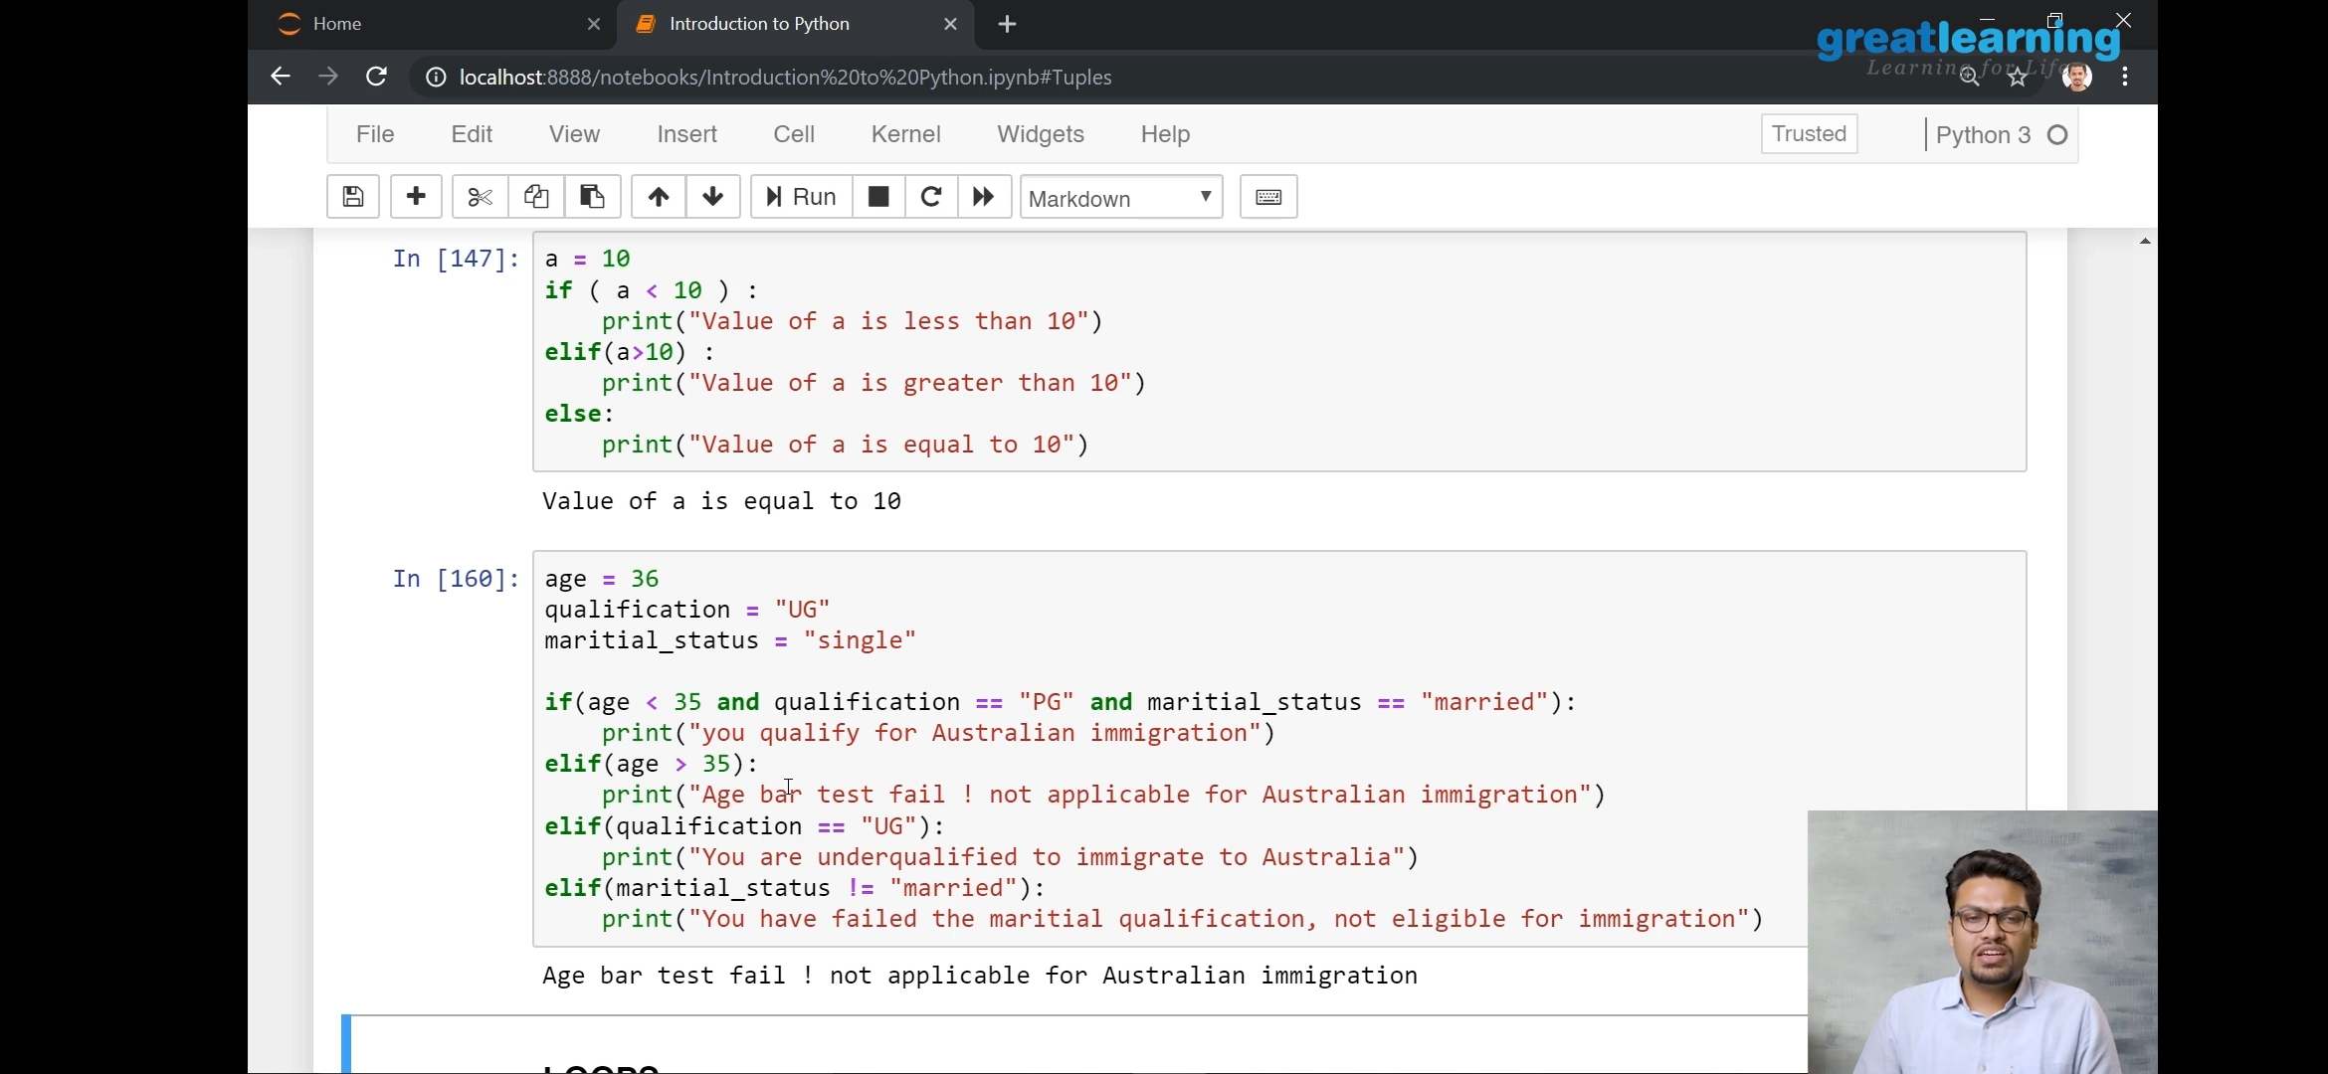

Coding Challenges Details: (Attach the snapshot and briefly write the report for the same)

def find_gcd(x, y):

while(y):

x, y = y, x % y

return x

l = [2, 4, 6, 8, 16]

num1=l[0]

num2=l[1]

gcd=find_gcd(num1,num2)

for i in range(2,len(l)):

gcd=find_gcd(gcd,l[i])

print(gcd)